**CASOS DE PRUEBA**

Luis Fernando Gonzalez Zambrano

Facultad Ingeniería, Universidad De Caldas

Análisis Y Diseño De Algoritmos

Dr. Luz Enith Guerrero Mendieta  
27 de mayo del 2024

1. Datos Red 5 Nodos

| **Caso de prueba** | **Partición respuesta generada** | **Valor de pérdida** | **Distribución de probabilidades de la partición respuesta** | **Tiempo de ejecución** |
| --- | --- | --- | --- | --- |
| 1 | {'Partición de ns': ' | A', 'Particion de cs': 'ABCD | BCD', 'Distancia de EMD': 0.0} | 0.0 | [0. 0. 1. 0. 0. 0. 0. 0. 0. 0. 0. 0. 0. 0. 0. 0.] | 2.9500858783721924 Segundos |
| 2 | {'Particion de ns': ' | A', 'Particion de cs': 'ABCDE | BCD', 'Distancia de EMD': 0.0} | 0.0 | [0. 0. 0. 0. 1. 0. 0. 0. 0. 0. 0. 0. 0. 0. 0. 0. 0. 0. 0. 0. 0. 0. 0. 0. 0. 0. 0. 0. 0. 0. 0. 0.] | 3.668726921081543 Segundos |
| 3 | {'Particion de ns': 'ABCD | BCD', 'Particion de cs': ' | AE', 'Distancia de EMD': 0.0} | 0.0 | [0.0, 0.0, 0.0, 0.0, 1.0, 0.0, 0.0, 0.0, 0.0, 0.0, 0.0, 0.0, 0.0, 0.0, 0.0, 0.0] | 3.656999349594116 Segundos |
| 4 | {'Particion de ns': 'E | ABC', 'Particion de cs': 'ABCD | ', 'Distancia de EMD': 0.02586} | 0.02586 | [0. 0. 0. 0. 0.5 0. 0. 0. 0. 0. 0. 0. 0. 0. 0. 0. 0. 0. 0. 0. 0.5 0. 0. 0. 0. 0. 0. 0. 0. 0. 0. 0. ] | 3.2046780586242676 Segundos |
| 5 | {'Particion de ns': 'AB | BCD', 'Particion de cs': ' | AE', 'Distancia de EMD': 0.0} | 0.0 | [1.0, 0.0, 0.0, 0.0] | 2.5945615768432617 Segundos |
| 6 | {'Particion de ns': 'D | A', 'Particion de cs': 'AC | CD', 'Distancia de EMD': 0.03125} | 0.03125 | [0.25 0.25 0. 0. 0.25 0.25 0. 0. ] | 2.6040048599243164 Segundos |
| 7 | {'Particion de ns': 'C | ABC', 'Particion de cs': 'AB | ', 'Distancia de EMD': 0.05859} | 0.05859 | [0. 0.5 0. 0. 0. 0.5 0. 0. ] | 2.6573069095611572 Segundos |
| 8 | {'Particion de ns': 'E | ABCE', 'Particion de cs': 'AB | ', 'Distancia de EMD': 0.05859} | 0.05859 | [0. 0.5 0. 0. 0. 0.5 0. 0. ] | 2.7109594345092773 Segundos |
| 9 | {'Particion de ns': 'C | ', 'Particion de cs': 'AB | BC', 'Distancia de EMD': 0.03125} | 0.03125 | [0.25 0.25 0. 0. 0.25 0.25 0. 0. ] | 3.7825522422790527 Segundos |
| 10 | {'Particion de ns': ' | ', 'Particion de cs': 'C | BC', 'Distancia de EMD': 0.0} | 0.0 | [0.5, 0.5] | 2.872455596923828 Segundos |
| 11 | {'Particion de ns': 'A | ABC', 'Particion de cs': 'C | ', 'Distancia de EMD': 0.0625} | 0.0625 | [0.5 0. 0.5 0. ] | 3.6017725467681885 Segundos |

1. 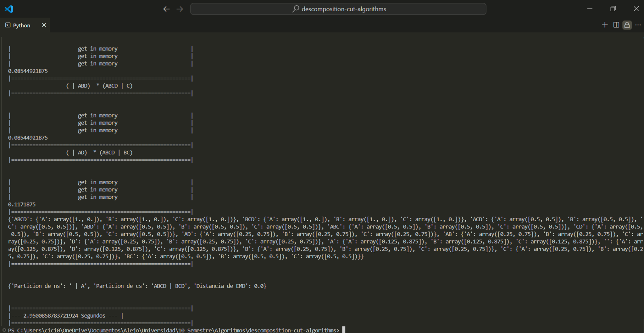
2. 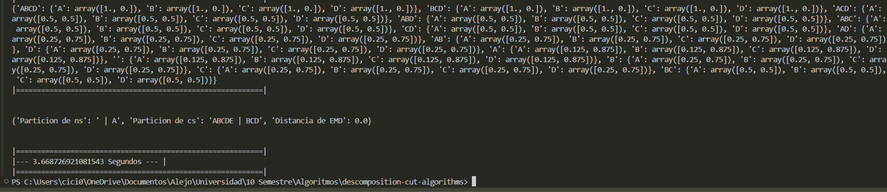
3. 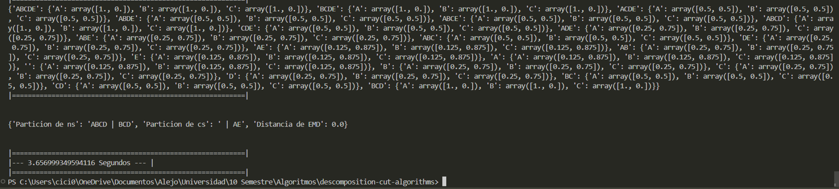
4. 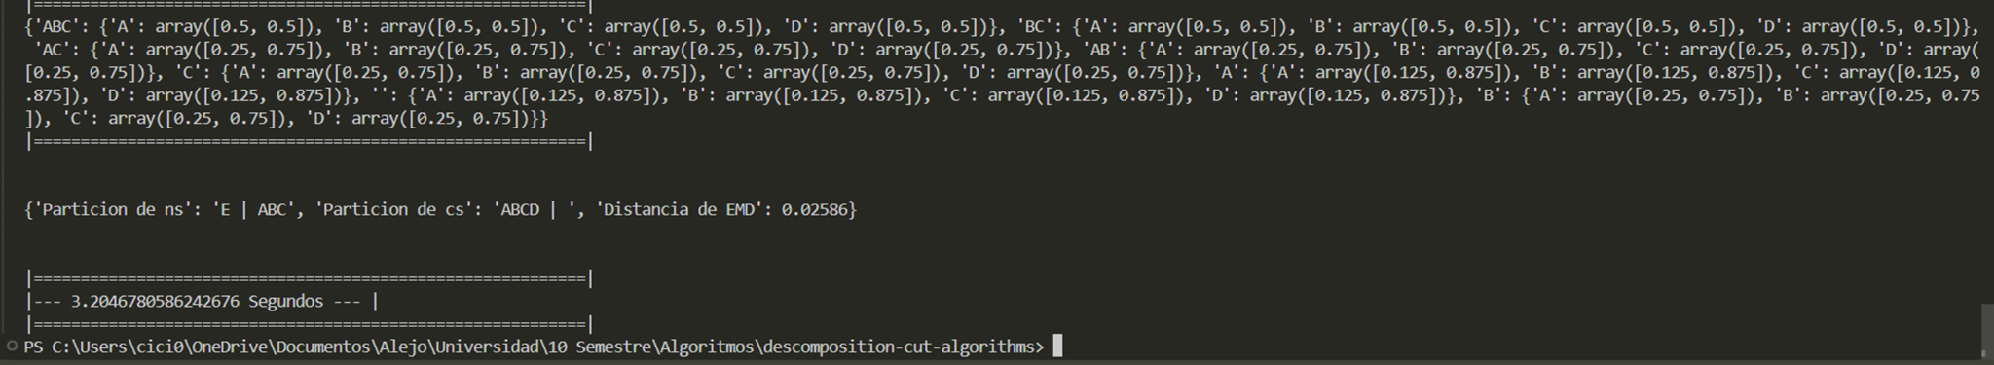
5. 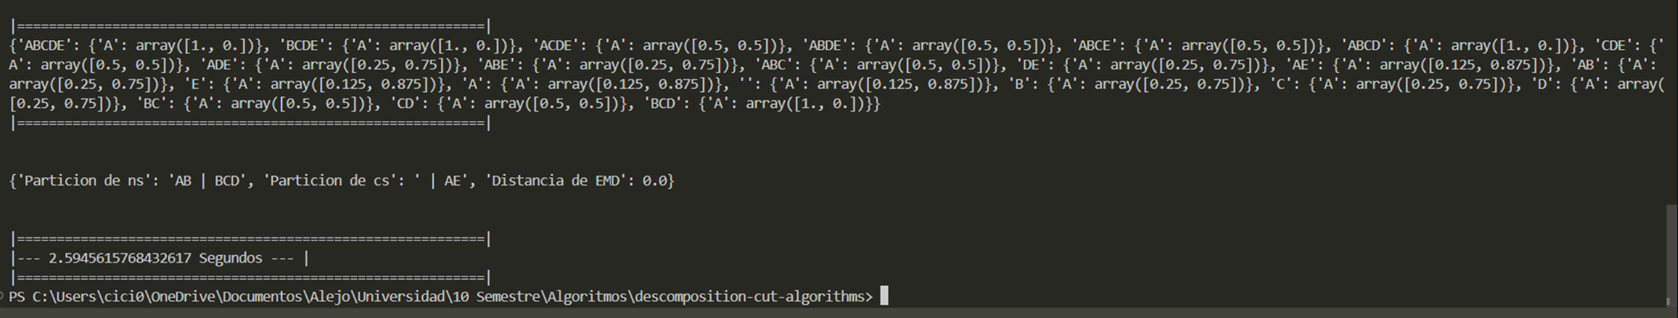
6. 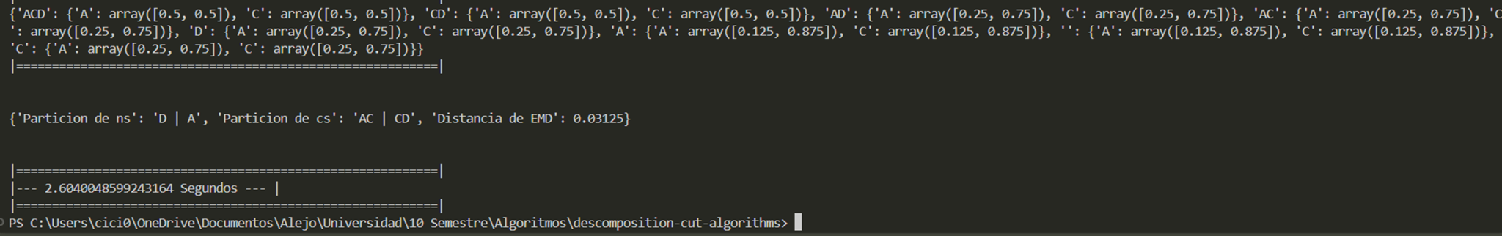
7. 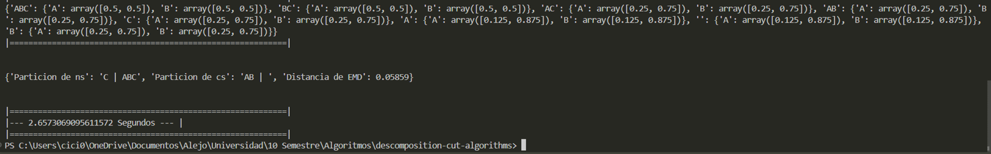
8. 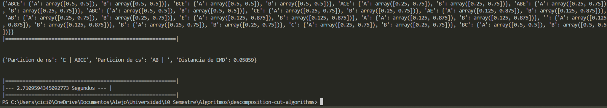
9. 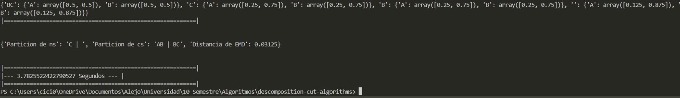
10. 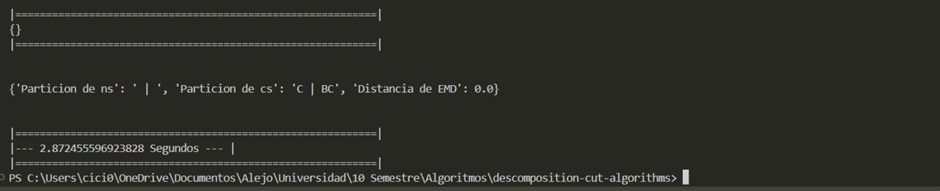
11. 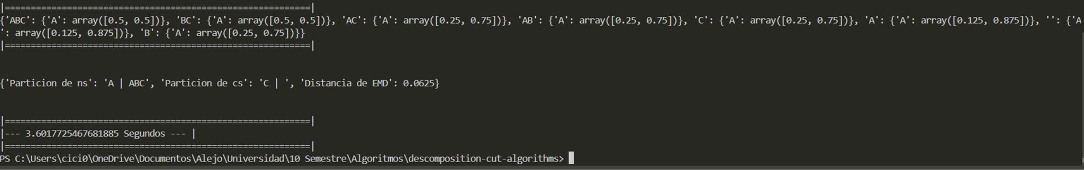

Corte

| **Caso de prueba** | **Partición respuesta generada** | **Valor de pérdida** | **Distribución de probabilidades de la partición respuesta** | **Tiempo de ejecución** |
| --- | --- | --- | --- | --- |
| 1 | partition (∅ᵗ⁺¹ | Aᵗᵗ) y (ABCDᵗ⁺¹ | BCDᵗ) | 0.0 | [0. 0. 1. 0. 0. 0. 0. 0. 0. 0. 0. 0. 0. 0. 0. 0.] | 1.7 |
| 2 | (∅ᵗ⁺¹ | Aᵗᵗ) y (ABCDᵗ⁺¹ | BCDEᵗ) | 0.0 | [0. 0. 1. 0. 0. 0. 0. 0. 0. 0. 0. 0. 0. 0. 0. 0.] | 1.83 |
| 3 | (∅ᵗ⁺¹ | Aᵗᵗ) y (ABCDEᵗ⁺¹ | BCDᵗ) | 0.0 | [0. 0. 0. 0. 1. 0. 0. 0. 0. 0. 0. 0. 0. 0. 0. 0. 0. 0. 0. 0. 0. 0. 0. 0.  0. 0. 0. 0. 0. 0. 0. 0.] | 1.97 |
| 4 | (∅ᵗ⁺¹ | Aᵗᵗ) y (ABCᵗ⁺¹ | BCDEᵗ) | 0.0 | [0.0, 0.0, 0.0, 0.0, 1.0, 0.0, 0.0, 0.0] | 2.14 |
| 5 | (∅ᵗ⁺¹ | Bᵗᵗ) y (ABCDEᵗ⁺¹ | Aᵗ) | 0.0253 | Original System: [0. 0. 0. 0. 0.125 0. 0. 0. 0. 0. 0. 0.  0.125 0. 0. 0. 0. 0. 0. 0. 0.375 0. 0. 0.  0. 0. 0. 0. 0.375 0. 0. 0. ] |  |
| 6 | (∅ᵗ⁺¹ | Cᵗᵗ) y (ACDᵗ⁺¹ | ADᵗ) | 0.0820 | [0.25 0.25 0. 0. 0.25 0.25 0. 0. | 0.02 |
| 7 | x | x | [0. 0.5 0. 0. 0. 0.5 0. 0. ] | 0.02 |
| 8 | x | x | [0. 0.5 0. 0. 0. 0.5 0. 0. ] | 0.02 |
| 9 | (∅ᵗ⁺¹ | Bᵗᵗ) y (BCᵗ⁺¹ | ACᵗ) | 0.15625 | [0.5 0. 0.5 0. ] | 1.9 |
| 10 | (∅ᵗ⁺¹ | Cᵗᵗ) y (BCᵗ⁺¹ | ᵗ) | 0.0703125 | [0.25 0. 0.75 0. ] | 4.07 |
| 11 | (∅ᵗ⁺¹ | Aᵗᵗ) y (ABCᵗ⁺¹ | Cᵗ) | 0.05859375 | [0.125 0.125 0. 0. 0.375 0.375 0. 0. ] | 1.05 |

#1



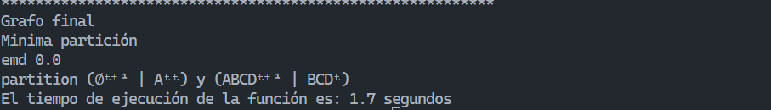

#2



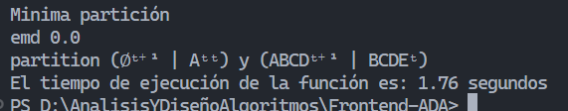

#3



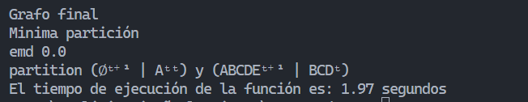

#4



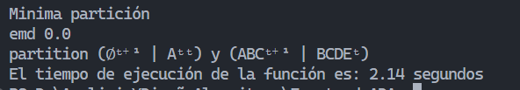

#5

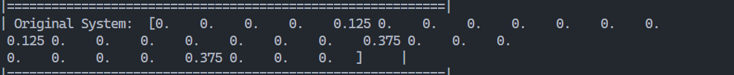

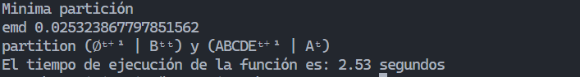

#6





#7

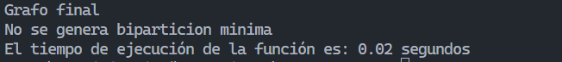

#8

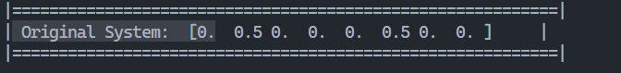

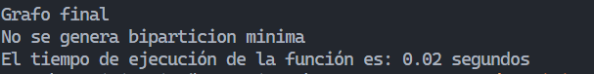

#9



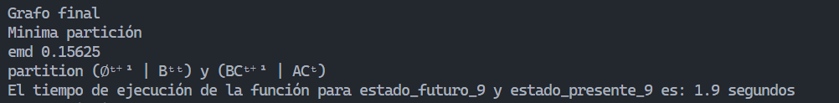

#10



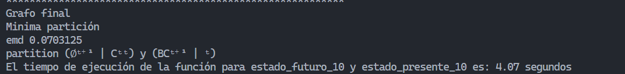

#11





| **Caso de prueba** | **Partición respuesta generada** | **Valor de pérdida** | **Distribución de probabilidades de la partición respuesta** | **Tiempo de ejecución** |
| --- | --- | --- | --- | --- |
| 1 | {'Particion de ns': 'ABCDF | BCD', 'Particion de cs': ' | AF', 'Distancia de EMD': 0.0} | 0.0 | [0. 0. 0. 0. 1. 0. 0. 0. 0. 0. 0. 0. 0. 0. 0. 0. 0. 0. 0. 0. 0. 0. 0. 0.  0. 0. 0. 0. 0. 0. 0. 0.] | 3.3686299324035645 Segundos |
| 2 | {'Particion de ns': ' | A', 'Particion de cs': 'ABCDEF | BCD', 'Distancia de EMD': 0.0} | 0.0 | [0. 0. 0. 0. 0. 0. 0. 0. 1. 0. 0. 0. 0. 0. 0. 0. 0. 0. 0. 0. 0. 0. 0. 0.  0. 0. 0. 0. 0. 0. 0. 0. 0. 0. 0. 0. 0. 0. 0. 0. 0. 0. 0. 0. 0. 0. 0. 0.  0. 0. 0. 0. 0. 0. 0. 0. 0. 0. 0. 0. 0. 0. 0. 0.] | 4.2990734577178955 Segundos |
| 3 | {'Particion de ns': 'ABCD | BCD', 'Particion de cs': ' | AE', 'Distancia de EMD': 0.0} | 0.0 | [0. 0. 1. 0. 0. 0. 0. 0. 0. 0. 0. 0. 0. 0. 0. 0.] | 3.1720921993255615 Segundos |
| 4 | {'Particion de ns': 'E | ABC', 'Particion de cs': 'ABCD | ', 'Distancia de EMD': 0.02586} | 0.02586 | [0. 0. 0. 0. 0.5 0. 0. 0. 0. 0. 0. 0. 0. 0. 0. 0. 0. 0.  0. 0. 0.5 0. 0. 0. 0. 0. 0. 0. 0. 0. 0. 0. ] | 2.8151299953460693 Segundos |
| 5 | {'Particion de ns': 'AB | BCD', 'Particion de cs': ' | AE', 'Distancia de EMD': 0.0} | 0.0 | [1. 0. 0. 0.] | 2.5448732376098633 Segundos |
| 6 | {'Particion de ns': 'CD | CD', 'Particion de cs': 'A | AF', 'Distancia de EMD': 0.03125} | 0.03125 | [0.25 0.25 0. 0. 0.25 0.25 0. 0. ] | 3.416999101638794 Segundos |
| 7 | {'Particion de ns': 'C | ABC', 'Particion de cs': 'AB | ', 'Distancia de EMD': 0.05859} | 0.05859 | [0. 0.5 0. 0. 0. 0.5 0. 0. ] | 2.5779366493225098 Segundos |
| 8 | {'Particion de ns': 'E | ABCE', 'Particion de cs': 'AB | ', 'Distancia de EMD': 0.05859} | 0.05859 | [0. 0.5 0. 0. 0. 0.5 0. 0. ] | 2.6458747386932373 Segundos |
| 9 | {'Particion de ns': 'C | F', 'Particion de cs': 'AB | BC', 'Distancia de EMD': 0.03125} | 0.03125 | [0.25 0.25 0. 0. 0.25 0.25 0. 0. ] | 2.4787182807922363 Segundos |
| 10 | {'Particion de ns': 'C | BC', 'Particion de cs': 'F | ', 'Distancia de EMD': 0.0625} | 0.0625 | [0.5 0. 0.5 0. ] | 2.4471263885498047 Segundos |
| 11 | {'Particion de ns': 'A | ABC', 'Particion de cs': 'C | ', 'Distancia de EMD': 0.0625} | 0.0625 | [0.5 0. 0.5 0. ] | 2.5329396724700928 Segundos |

1. 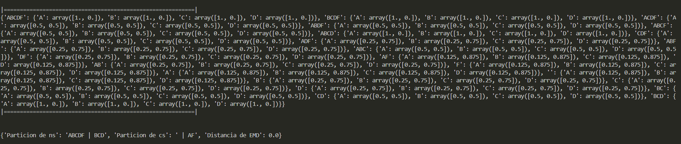
2. 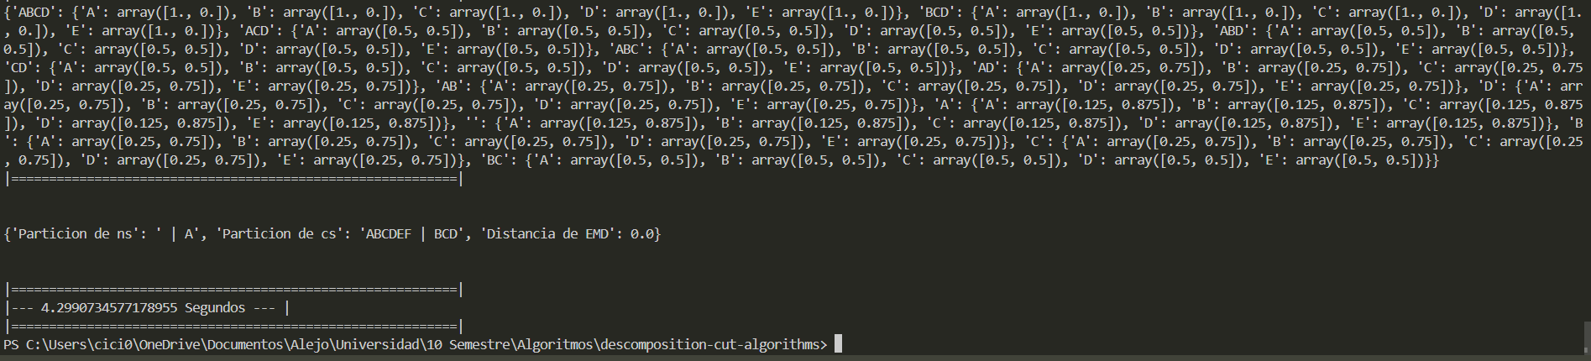
3. 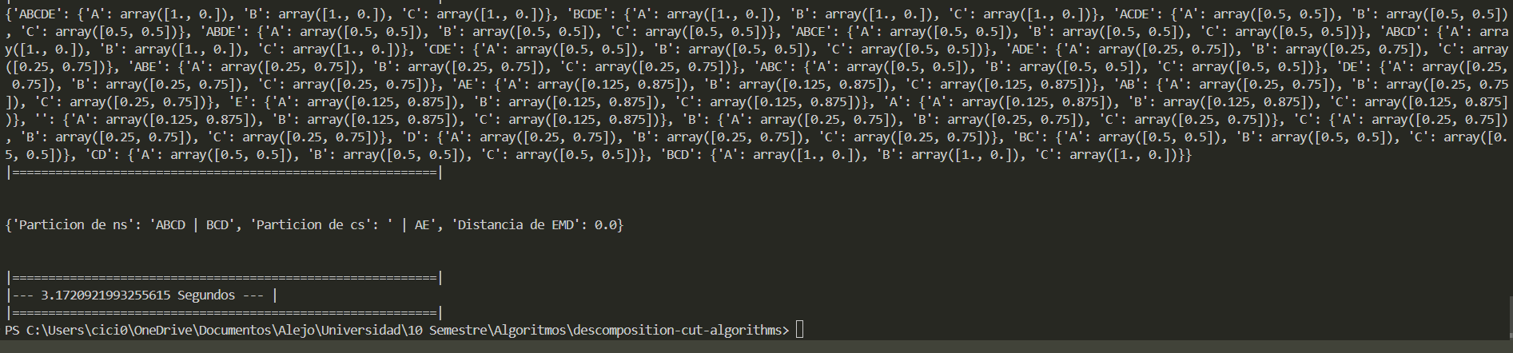
4. 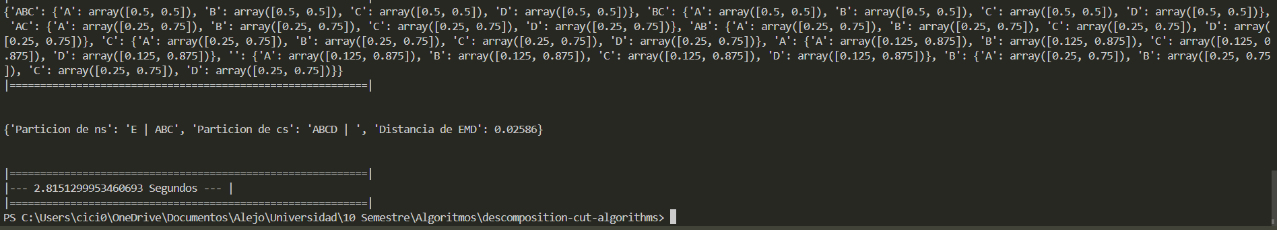
5. 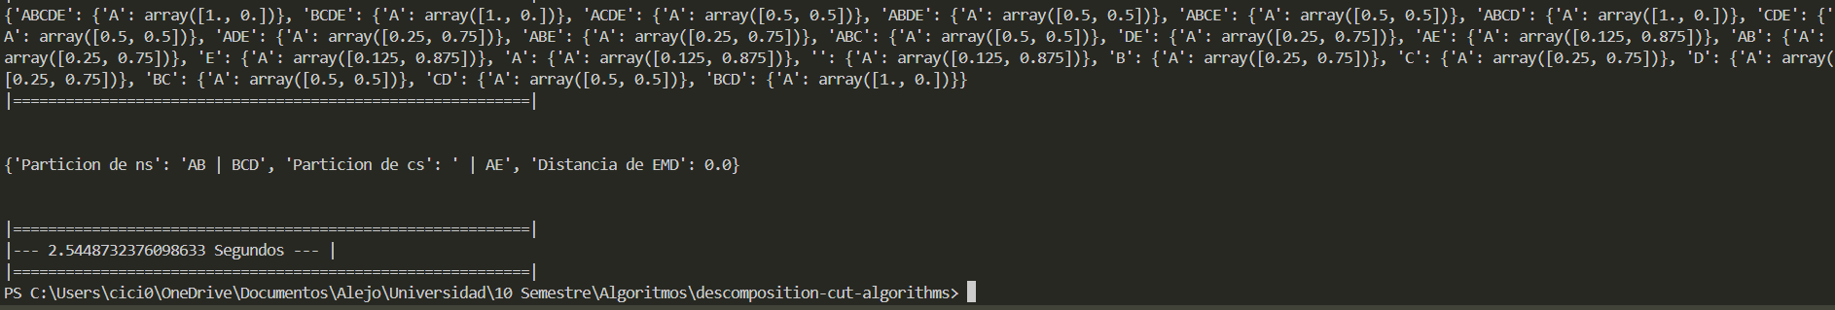
6. 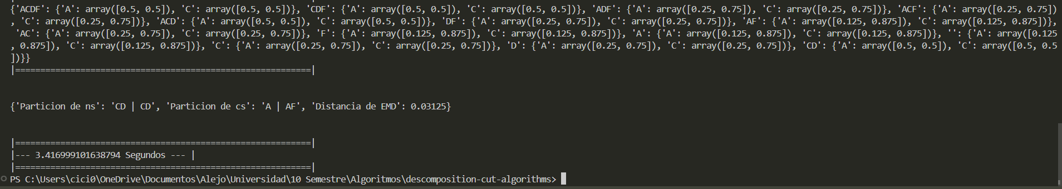
7. 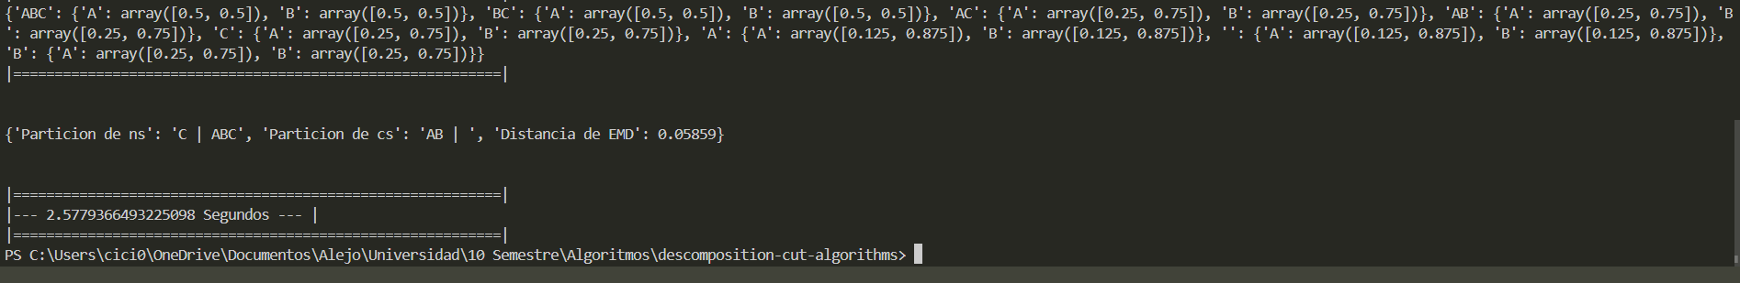
8. 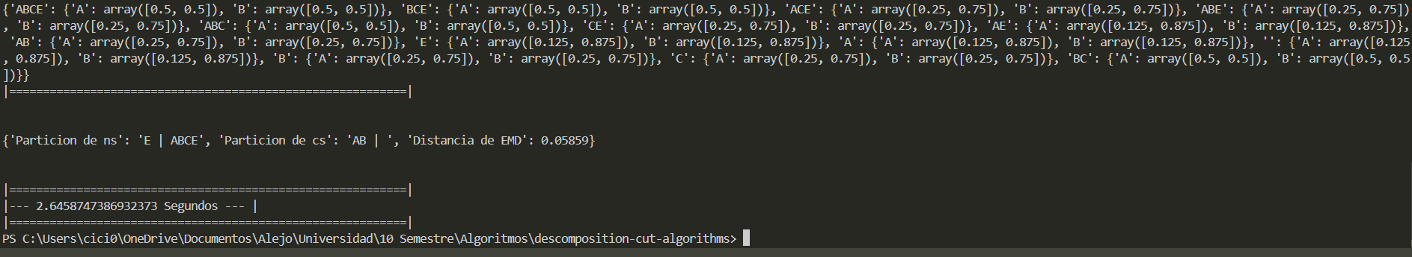
9. 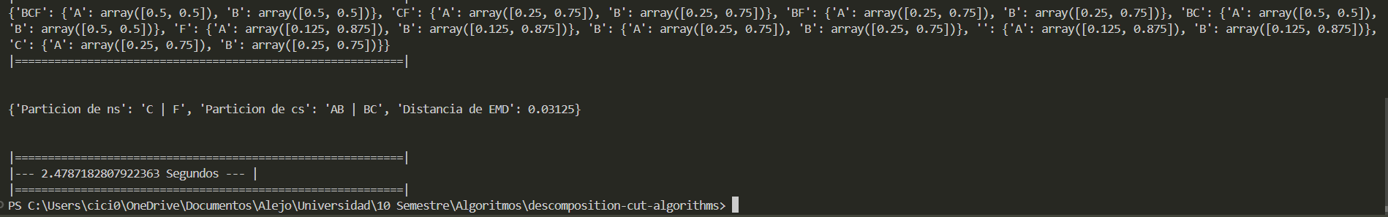
10. 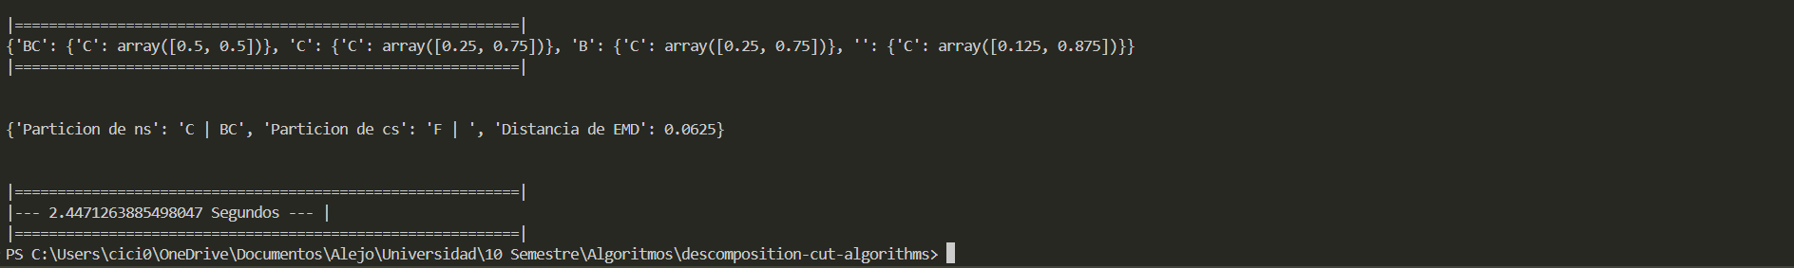
11. 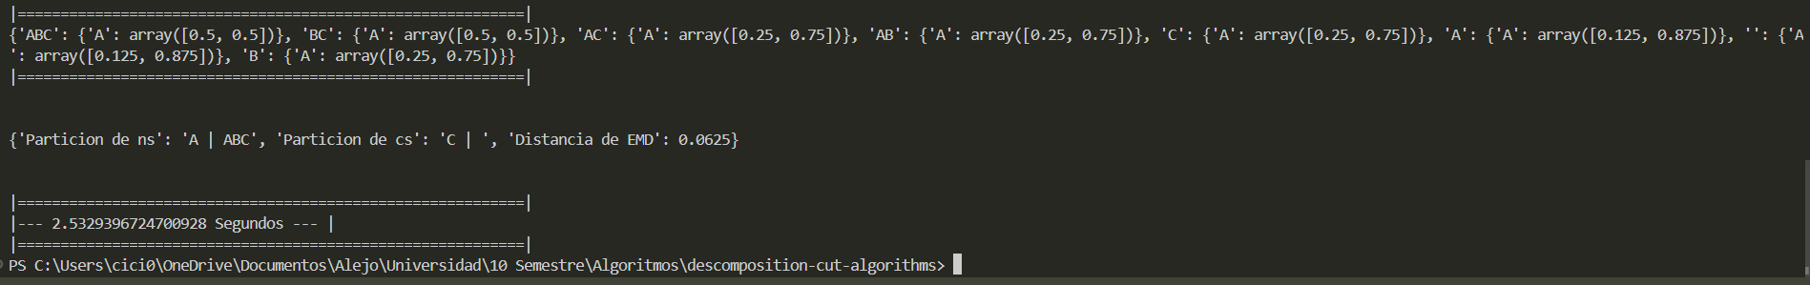

corte

| **Caso de prueba** | **Partición respuesta generada** | **Valor de pérdida** | **Distribución de probabilidades de la partición respuesta** | **Tiempo de ejecución** |
| --- | --- | --- | --- | --- |
| 1 | (∅ᵗ⁺¹ | Fᵗᵗ) y (ABCDFᵗ⁺¹ | ABCDᵗ) | 0.0 | [0.125 0. 0.125 0. 0. 0. 0. 0. 0.375 0. 0.375 0. 0. 0. 0. 0. ] | 255 |
| 2 | (∅ᵗ⁺¹ | Fᵗᵗ) y (BCt ᵗ⁺¹ | Cᵗ) | 458.984.375 | [0.125 0. 0.125 0. 0. 0. 0. 0. 0.375 0. 0.375 0.  0. 0. 0. 0. ] | 01.01 |
| 3 | (∅ᵗ⁺¹ | Aᵗᵗ) y (ABCDEtᵗ⁺¹ | BCDᵗ) | 0.0 | [0. 0. 0. 0. 0. 0. 0. 0. 1. 0. 0. 0. 0. 0. 0. 0. 0. 0. 0. 0. 0. 0. 0. 0.  0. 0. 0. 0. 0. 0. 0. 0. 0. 0. 0. 0. 0. 0. 0. 0. 0. 0. 0. 0. 0. 0. 0. 0.  0. 0. 0. 0. 0. 0. 0. 0. 0. 0. 0. 0. 0. 0. 0. 0.] | 1.4 |
| 4 | (∅ᵗ⁺¹ | ᵗᵗ) y (ABCt +ᵗ⁺¹ | ABCDEᵗ) | 0.0 | [0. 0. 0. 0. 0. 0. 0. 0. 1. 0. 0. 0. 0. 0. 0. 0. 0. 0. 0. 0. 0. 0. 0. 0.  0. 0. 0. 0. 0. 0. 0. 0. 0. 0. 0. 0. 0. 0. 0. 0. 0. 0. 0. 0. 0. 0. 0. 0.  0. 0. 0. 0. 0. 0. 0. 0. 0. 0. 0. 0. 0. 0. 0. 0.] | 1.75 |
| 5 | (∅ᵗ⁺¹ | Bᵗᵗ) y (ABCDEtᵗ⁺¹ | Aᵗ) | 0.01352 | [0. 0. 0. 0. 0. 0. 0. 0. 0.125 0. 0. 0.  0. 0. 0. 0. 0. 0. 0. 0. 0. 0. 0. 0.  0.125 0. 0. 0. 0. 0. 0. 0. 0. 0. 0. 0.  0. 0. 0. 0. 0.375 0. 0. 0. 0. 0. 0. 0.  0. 0. 0. 0. 0. 0. 0. 0. 0.375 0. 0. 0.  0. 0. 0. 0. ] | 1.43 |
| 6 | x | x | [0.125 0. 0.125 0. 0. 0. 0. 0. 0.125 0. 0.125 0.  0. 0. 0. 0. 0. 0. 0. 0. 0. 0. 0. 0.  0. 0. 0. 0. 0. 0. 0. 0. 0.125 0. 0.125 0.  0. 0. 0. 0. 0.125 0. 0.125 0. 0. 0. 0. 0.  0. 0. 0. 0. 0. 0. 0. 0. 0. 0. 0. 0.  0. 0. 0. 0. ] | 0.09 |
| 7 | x | x | [0. 0. 0. 0. 0.5 0. 0. 0. 0. 0. 0. 0. 0. 0. 0. 0. 0. 0.  0. 0. 0.5 0. 0. 0. 0. 0. 0. 0. 0. 0. 0. 0. ] | 0.06 |
| 8 | x | x | [0. 0. 0. 0. 0. 0. 0. 0. 0.125 0. 0. 0.  0. 0. 0. 0. 0. 0. 0. 0. 0. 0. 0. 0.  0.125 0. 0. 0. 0. 0. 0. 0. 0. 0. 0. 0.  0. 0. 0. 0. 0.375 0. 0. 0. 0. 0. 0. 0.  0. 0. 0. 0. 0. 0. 0. 0. 0.375 0. 0. 0.  0. 0. 0. 0. ] | 0.08 |
| 9 | x | x | [0. 0. 0.5 0. 0. 0. 0. 0. 0. 0. 0.5 0. 0. 0. 0. 0. ] | 0.04 |
| 10 | (∅ᵗ⁺¹ | Fᵗᵗ) y (BCt ᵗ⁺¹ | Cᵗ) | 458.984.375 | [0.125 0. 0.125 0. 0. 0. 0. 0. 0.375 0. 0.375 0.  0. 0. 0. 0. ] | 01.01 |
| 11 | x | x | [0.125 0. 0.125 0. 0. 0. 0. 0. 0.375 0. 0.375 0. 0. 0. 0. 0. ] | 0.06 |

#1

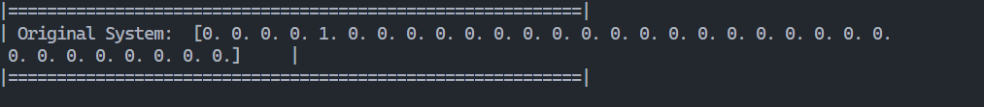

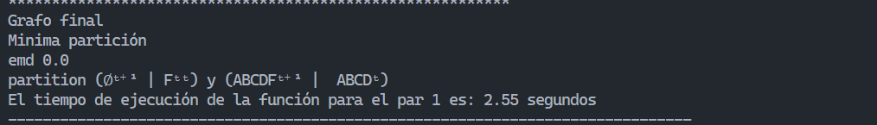

#3

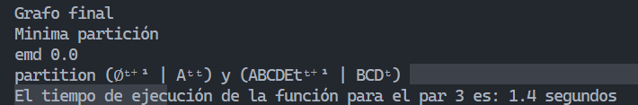

#4

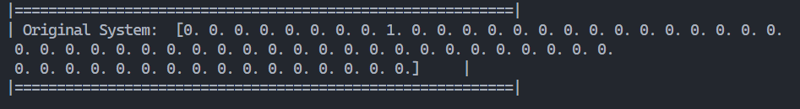

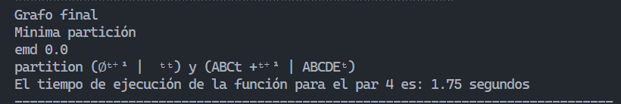

#5

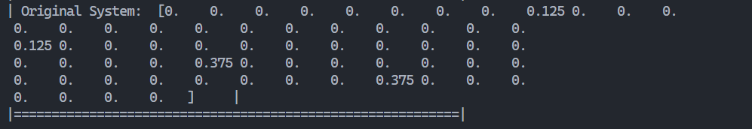

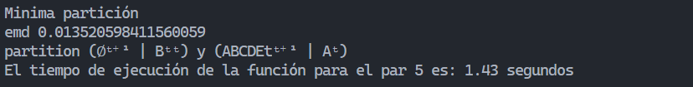

#6

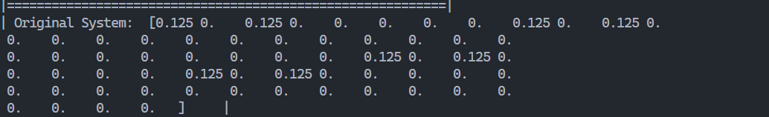

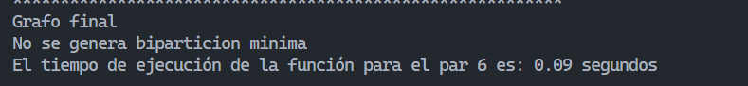

#7



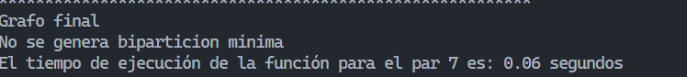

#8

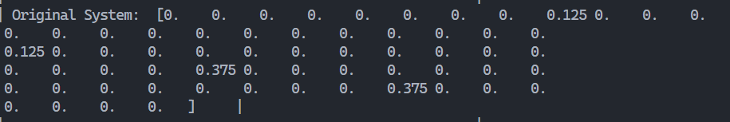

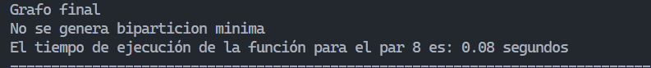

#9

[0. 0. 0.5 0. 0. 0. 0. 0. 0. 0. 0.5 0. 0. 0. 0. 0. ]



#10

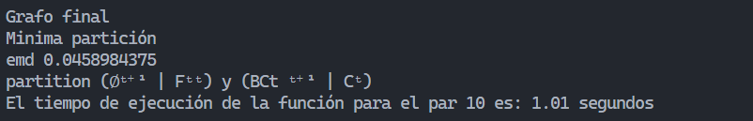

#11

